EXPERIMENT (4)

AIM
To perform UPDATE and DELETE operations on the Hostel Management System tables.

DESCRIPTION
UPDATE modifies existing records. DELETE removes records from database tables.

SYNTAX
UPDATE table_name SET column=value WHERE condition;
DELETE FROM table_name WHERE condition;

Questions and Answers
1. Update the room status of RoomID 101 to Available.
UPDATE Hostel_Rooms
SET RoomStatus='Available'
WHERE RoomID=101;
SELECT * FROM Hostel_Rooms;
2. Delete the student whose StudentID = 203.
DELETE FROM Hostel_Student
WHERE StudentID=203;
SELECT * FROM Hostel_Student;
3. Update the experience of Warden W101 to 15 years.
UPDATE Hostel_Warden
SET Experience=15
WHERE WardenID='W101';
SELECT * FROM Hostel_Warden;
4. Delete all hostel blocks having TotalRooms < 35.
DELETE FROM Hostel_Block
WHERE TotalRooms<35;
SELECT * FROM Hostel_Block
Questions
1) Update the room status of RoomID = 101 to 'Available'.
Table Used: HOSTEL_ROOMS
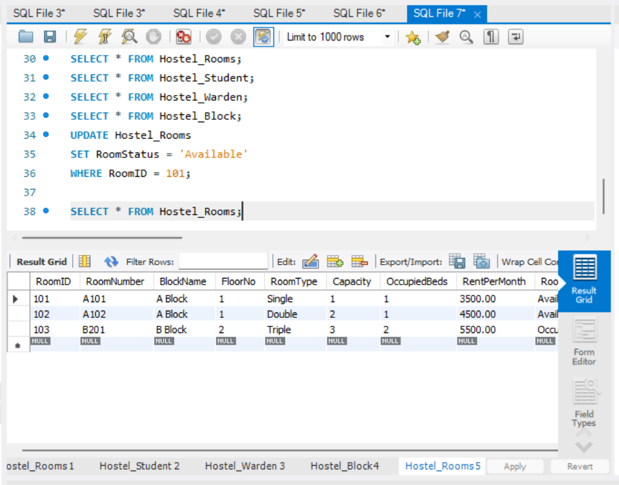
2) Delete the student whose StudentID = 203.
Table Used: HOSTEL_STUDENT
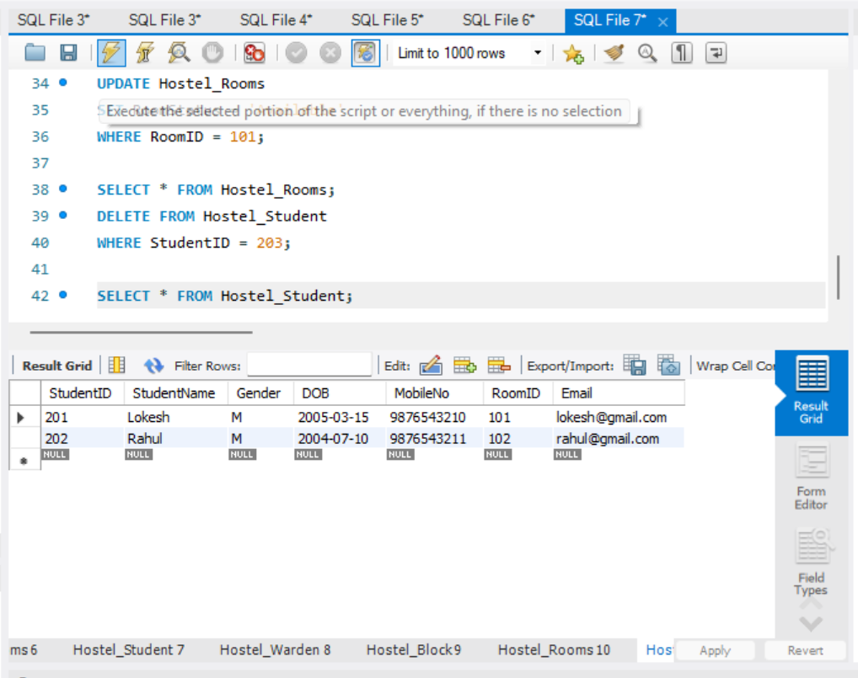
3) Modify the experience of Warden 'W101' to 15 years.
Table Used: HOSTEL_WARDEN
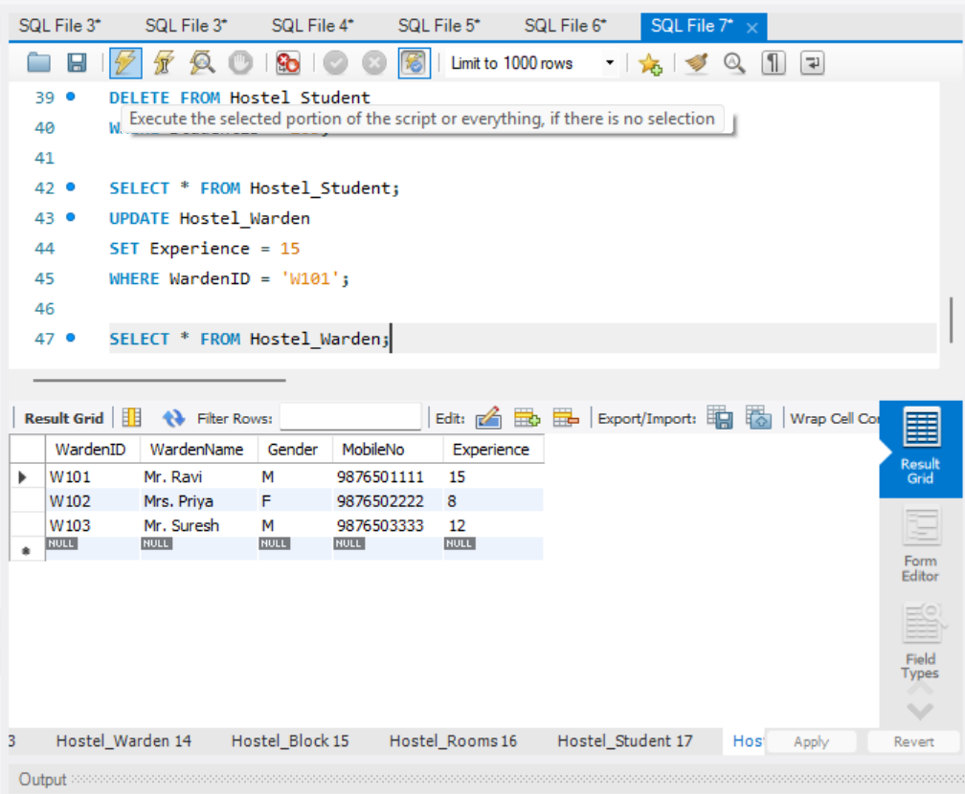
4) Remove all hostel blocks having TotalRooms less than 35.
Table Used: HOSTEL_BLOCK
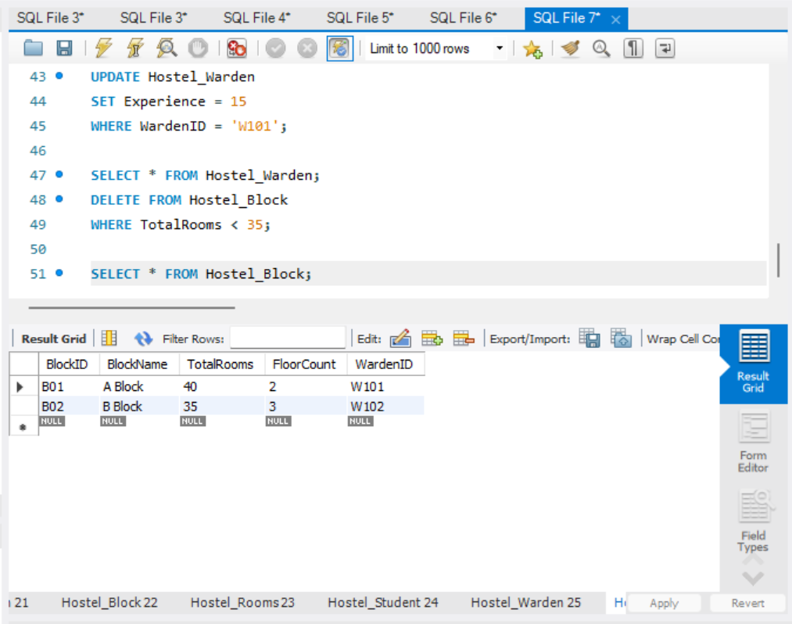

RESULT
Thus, the UPDATE and DELETE commands were successfully executed on the Hostel Management System tables.

